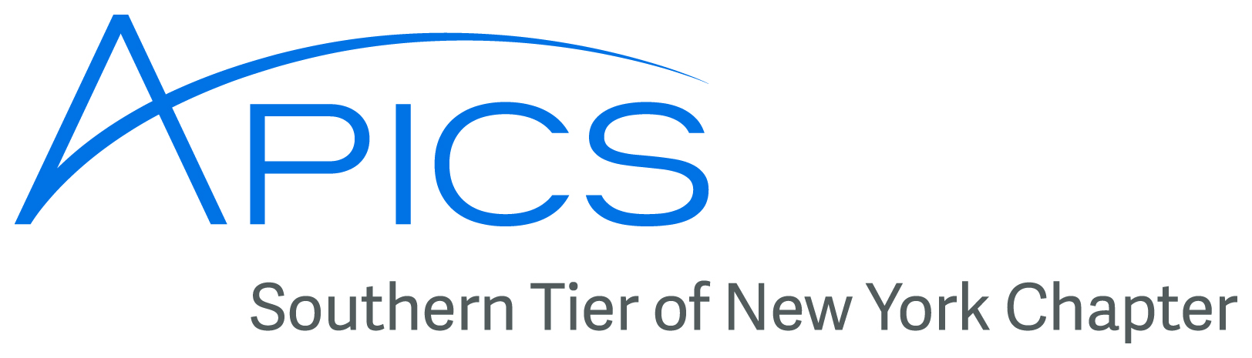
www.stapics.org

NO DINNER MEETING THIS MONTH

APICS Update from Don Sheldon, Director of Education

APICS Student Competition in Albany – Our area has not had representation at the popular and growing APICS college student supply chain competition but, as you know, this is about to change. Our local chapter has sponsored three student teams to compete in Albany from Binghamton University.

Join Us February 7th and 8th, 2014 in Albany, NY!

On February 7th and 8th will be held in Albany NY. It will be held in conjunction with the District Training event, so we hope you can attend for the training and also meet and network with the students.

Some highlights about the weekend:

Due to popular demand -- the case competition has been increased to 14 Teams on both the Graduate and Undergraduate track. This is an increase of 16 Students who can participate in the event. There is still a wait list too leaving more room to grow the event!

Thanks to the great work of Chapters and Members -- there is an even more diverse group of schools being represented this year!

The schools represented are:

• Binghamton University (YAY BU!)
• SUNY Buffalo
• Clarkson University
• SUNY Farmingdale
• Maine Maritime Academy
• NJIT
• RPI
• SUNY Plattsburgh
• Rutgers University
• Seton Hall University
• Syracuse University
• UMass Amherst
• UMass Dartmouth
• UCONN
• WPI.

For your information there will be three (3) mini-workshops for the District Meeting agenda on Saturday morning.

Each workshop will run for 2.5 hrs and be focused on three core themes:

1. IT Analytics and Website Intelligence with John Capron (follow-on to November)
2. Leaning up Operations Projects/STEPing into the Future with Cynthia Kalina-Kaminsky
3. Membership Matters and Member Needs Survey

Don't miss any of the benefits from all three sessions on Saturday morning!

Make your hotel reservations now -- below is a link to the Group Reservation portal for our Event on February 7th and 8th at the Albany Marriott. If you prefer to call to make your hotel reservations please call 1-800-443-8952 and remember to ask for the APICS District Member room rate of $99/night. Book your room by 01/17 to secure your hotel rate.

Register for the District event (no charge to register) at the district site:
www.apicsnortheast.org . This must be done IN ADDITION to your hotel reservations.
Please read the form carefully and fill it out completely!

Marriott hotel offering your special group rate:

Book your group rate: APICS District Meeting >>

http://www.marriott.com/meeting-event-hotels/group-
corporate-travel/groupCorp.mi?
resLinkData=APICS%20District%20Meeting^albny%60acsacsa%6099.00%60USD
%60false%602/7/14%602/9/14%601/17/14&app=resvlink&stop_mobi=yes

Thanks!

Don Sheldon
Director, Education
Southern Tier of NY Chapter
APICS

New APICS Certification Maintenance Application Process

As an APICS designee, you know that you must meet certain requirements to maintain your certification. This is to preserve the integrity and value of APICS certification programs. The APICS certification maintenance programs allow designees to acquire ongoing knowledge in their field and demonstrate a commitment to lifelong learning through professional development activities.

As of January 13, 2014, you will be able to maintain your certification with a simpler application process. While maintenance requirements remain the same, you will no longer be required to report detailed maintenance activities to APICS in the online application. Instead, you will be required to submit documentation only if you are audited by APICS. In addition, you will be immediately notified if you are being audited or your application has been accepted.

Note that you may now apply for certification maintenance at any time, rather than having to wait until the fifth year of your certification. In addition, your new maintenance due date will be five years after your current maintenance due date.

These improvements are designed to simplify the maintenance process and encourage more designees to maintain their hard-earned certifications. Additional information about the APICS certification process can be found on our website http://www.apics.org/careers-education-professional-development/certification/maintenance.

Thank you for your support of APICS certification programs. If you have questions, please contact certification@apics.org.



Sponsors to date for

6th Annual APICS Northeast District Student Case Competition

As of January 3, 2014 we have the following sponsors for our competition:
Platinum
APICS Foundation
APICS Northeast District
Gold
Regeneron Pharmaceuticals, Inc.
Silver
APICS Granite State Chapter
APICS Monadnock Chapter
APICS New Haven Chapter
APICS New York City/Long Island Chapter
APICS South Shore Chapter
APICS Southern New Hampshire Chapter
TQM Works Consulting, Inc.
Bronze
APICS Buffalo Chapter
APICS Champlain Valley Chapter
APICS MidHudson Chapter
APICS Rochester Chapter
Zampello and Associates
Friends
APICS Central New York Chapter
APICS Danbury Chapter
APICS Fairfield County Chapter
APICS Maine Chapter
Special Recognition
Extra special thanks and appreciation to the following who are financially supporting teams directly:
APICS Albany Capital District Chapter
APICS Champlain Valley Chapter
APICS New York City / Long Island Chapter
APICS Northern NJ Chapter
APICS Southern Tier of NY Chapter
APICS Tappan Zee Chapter
APICS Western Massachusetts Chapter
APICS Worcester County Chapter

When

FRIDAY
February 7, 2014
SATURDAY
February 8, 2014



Board of Directors 2013-2014

President

Dave Gardner, CPIM

dgardner@emtmetals.com

Executive VP /Director of Finance

Steve Whited

steven.whited@acco.com

Secretary

Debbie Unkel, CPIM

deb.unkel@raymondcorp.com

Director of Membership/Director of Chapter Standards/ Director of Online Publication

Lee Schechter , CPIM

lschechter@stny.rr.com

Director of Programming and Marketing

Michael LoSapio

Michael.LoSapio@SynergyResources.net

Director of Publicity

Kelly Norieka

Kelly.norieka@lmco.com

2nd Director of Publicity

Chris Reinwald

creinwald@gmail.com

Director of Education

Don Sheldon, CPIM, CIRM, CSCP

dsheldon@sheldoninc.com

Director at Large

Steve Stanchak, CPIM

steve.stanchak@infoprint.com

Director of Student Relations

Brian Arrnold

barnold@amphenol-aao.com

2nd Director of Student Relations

Don Sheldon, CPIM, CIRM, CSCP

dsheldon@sheldoninc.com

Director of Communications

April McWeeney, CPIM

april.mcweeney@acco.com

Southern Tier APICS
PO Box 1107
Binghamton NY 13902-1107

